Living With Spice E-News, January 2014

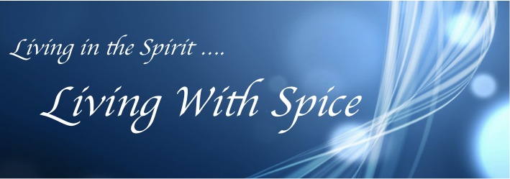

Happy New Year Everyone! Welcome to our January E-News for 2014

In this edition of Living With Spice E-News, please enjoy the following articles:
- Travelling With Spice - Travel Experiences for Women
- Turn Chaos to Organised Bliss
- “I Am A Girl” – A Compelling Documentary Film
- Make Your Dreams a Reality – The 3 Step Process
- Conversations with a Life Coach
- Trusting Your Intuition
- Youths Volunteer in Cambodia – My Daughter’s Effect on a Nation Desperate to Learn
- Life Enhancement Workshops
- Events
- Subscribe to LWS E-News

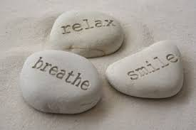
We hope you have enjoyed celebrating with your family and friends and you are now ready to embrace the new year with enthusiasm. At this time we often reflect on the past 12 months, and resolve to be better organized or more ‘this’ and less ‘that’, for the year ahead. It can be easy to allow ourselves to get discouraged before we even get started.

So, before you get hung up on ‘what’s next’ and getting back into the pounding pace of the year – try ‘relaxing, breathing, and smiling’. The year will come and go like the last one, so you may as well decide to feel good about it.

We all want to feel happy and fulfilled in our work and personal life. Often our sense of fulfillment is a direct result of whether we have been successful in achieving what we set out to do. A great practice is to review what worked well, and what didn’t in the past year. Reflection is just as important as good planning. Both are key to ensuring you get the results you’re aiming for, as well as increasing your understanding as to why you didn’t achieve what you had planned.

Sometimes, stuff happens and our expectations can be dashed. Rather than becoming discouraged, take note of the positives, even if the outcomes are not what you hoped for. The setbacks can give us helpful insights and feedback so we can adjust our approach and the action steps we take next time.

Our sense of fulfillment in life is also influenced by how we perceive our world, what we tell ourselves about our experiences, and the meaning we give them. Being grateful for all the experiences we have does wonders for inspiring creativity and innovation, and boosts our health and wellbeing - mentally, physically, emotionally and spiritually. So, as you gather yourself after recent celebrations, take some moments to be Still. Relax. Breathe. Enjoy what you have achieved, and Smile. Every experience is there to bring us some learning, which is ultimately for our benefit.
Rebecca Novacek – Founder of Living With Spice

# 1. Travelling With Spice – Travel Experiences for Women

A Tuscan Experience

In 2013 Living With Spice teamed up with Travel Charm to create unique travel experiences designed to give women the opportunity to rediscover themselves whilst exploring the world. Many women over 40 reach a stage in life when they are ready to take some ‘time out’ to reconnect with themselves. This often comes when the children (now young adults) begin to seek independence (or not), or perhaps there has been a change in career direction, relationships or even health choices.

For some, significant changes in life can create confusion or a sense of loss of identity or uncertainty about the way forward. Having the opportunity to step out of the usual surrounds can provide a fresh perspective or more fertile ground to re-evaluate what’s important in life and perhaps consider alternative options.

Whatever the reason, the chance to travel with other like-minded women in the comfort of a smaller group, can be just what you, or your partner, is looking for. “Travelling With Spice” offers a genuine combination of exceptional travel services by Travel Charm, with the life-enhancing expertise of Living With Spice. Both Cindy and Rebecca have designed some wonderful travel experiences for women, to give you that new lease of life that you have been looking for.

In September we are headed to Italy for 12 days, stopping in historical Rome and then enjoying time in the beautiful landscape of Tuscany. Other destinations include Cambodia & Vietnam at the end of the year, Vanuatu mid-year, with India, France and Greece coming soon.

For those who are feeling the need to connect with nature, we are planning a trip to Outback Australia, specifically designed for women who are beginners and would like to try something new, with the comfort and safety of an experienced guide!
Connecting with nature on a regular basis (no matter where you are) is an important and necessary part of living in Spirit and connecting with our true self. Locking ourselves up in the busyness of our lives, our home and workplace can disconnect us from the very essence of who we are. So ladies, it’s time to take care of yourself and get back to who YOU really are.

If you would like to know more, please visit http://www.travelcharm.com.au and register your interest, or send an email to Rebecca@livingwithspice.com or Cindy@travelcharm.com.au

There will be a number of social events and information evenings this year to discover more about our trips and meet other like-minded women. So stay tuned for dates and locations.

Contact Living With Spice to learn how you can create a life you love with our personal coaching services.

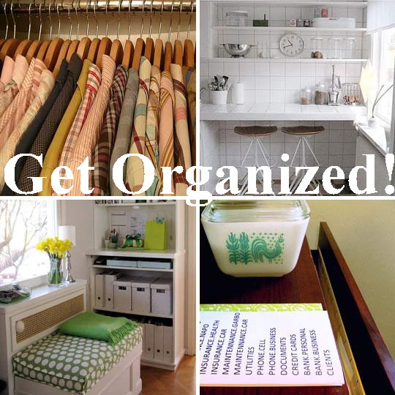
#2. Turn Chaos to Organised Bliss

For some people, the start of the year can feel very overwhelming. We’ve reflected over the past year, allowed ourselves to dream big, created some realistic goals, and drawn up some plans for the year ahead. However, we still feel and see a lot of chaos and clutter around. What now?

Clutter in our life is very debilitating mentally, physically, emotionally and spiritually. It affects our health and relationships, our sense of wellbeing, and our productivity.

If this sounds familiar, and being organized is not your forte, then you need to enlist the assistance of a professional organizing consultant.
An organizing consultant can help you:

- Master your time-management
- Implement simple systems to help you with productivity and profitability, and
- Get you back on top of your game, stress-free!

For more information on ‘How to be De-Clutter Your Life’ and take steps to get organized in your work and home life – email Rebecca@simplyorganise.com and book in some time for either a chat or a “Clean Up” coaching session.

Simply Organise - Professional Organising Consultant. http://www.simplyorganise.com

# 3. “I Am A Girl” – A Compelling Documentary Film

Join us for an Evening of Champagne and Canapés – A Screening and Fundraiser Night on Wednesday 26th March, 2014 (Sydney)

Recently, the extraordinary Australian Film Director and Producer – Rebecca Barry, debuted her documentary film “I Am A Girl”. Following her own personal crisis and life-changing moment surviving the Samoan Tsunami in 2009, Rebecca was called to capture the personal stories of young girls and their fight to survive incredible gender discrimination. Aged between 16 and 19 years of age, girls from around the globe are grappling with tragic inequality because they are born female. With little or no access to health, education and nutrition (compared to males in their community) their lives are severely impacted so that hope of any positive future is almost unachievable. Whilst their predicament of inequality is not new to us, Rebecca’s skill at capturing their personal stories at a grassroots level, is emotionally engaging and personally compelling. The film aims to break open the truth and the extent of gender discrimination that widely exists around the world.
Figure 1 - Breani - USA

Far from being a film of hopelessness, these young girls show incredible determination to rise above their circumstances. Though their culture and social contexts vary, they demonstrate inner strength and courage as they move towards becoming extraordinary and empowered young women.

The need for ‘women to support women’ through education, health, personal leadership, love, and a willingness to tell their story, cannot be underestimated. The Not-For-Profit organisations – “Because I Am A Girl” and “Plan" are dedicated to sharing these individual stories and educating young men and women about the importance of equal access to education, health and nutrition.

Living With Spice and Travel Charm are working to assist women to be empowered leaders of themselves. This means helping them to recognise their self worth and value as individuals, and assist them to be the best they can be. Women supporting women provides young girls with meaningful role-models and the support they need to create lives of opportunity, meaning, purpose and fulfillment.

“Travelling With Spice” supports the work and philosophy of “BecauseIAmAGirl” and “Plan”. Every person who books travel with Travelling With Spice will be contributing towards their cause that supports young girls to become empowered young women.

To show your support, register to attend the Screening and Fundraiser Evening of
“I Am A Girl” on Wednesday 26th March, 7.00 – 9.00pm (Sydney).
Register here: Rebecca@LivingWithSpice.com
Cost: $25 pp - Drinks and canapés on arrival at 6.30pm.

#4. Make Your Dreams a Reality – The 3-Step-Process to Achieving What You Really Want.
To receive your FREE CD on “Creating A Mindset for Success”, go to www.livingwithspice.com

When New Year comes around, you’re not alone if you think making resolutions is a waste of time. They seldom work because they are made without real planning, commitment or follow-through. It’s important to plan to be happy and feel fulfilled in life. This means we need to set targets that are realistic, and to keep it clear and simple. Using the 3-Step-Process will reduce overwhelm and get you on track to achieving what you really want.

To get started -

Step 1. Choose 3 (no more than 5) things that you really want to achieve in either your life, work, relationships, lifestyle, health, finances, or community.

Step 2. Give yourself some quiet time and imagine having achieved each of these outcomes within a specific timeframe. Imagine how you are feeling (engage your emotions), what you are seeing in your life (visualize), and what are you telling yourself when you have already achieved these things. Put some emotion into it. Get out of your head and really feel what it’s like once you have achieved your goal.
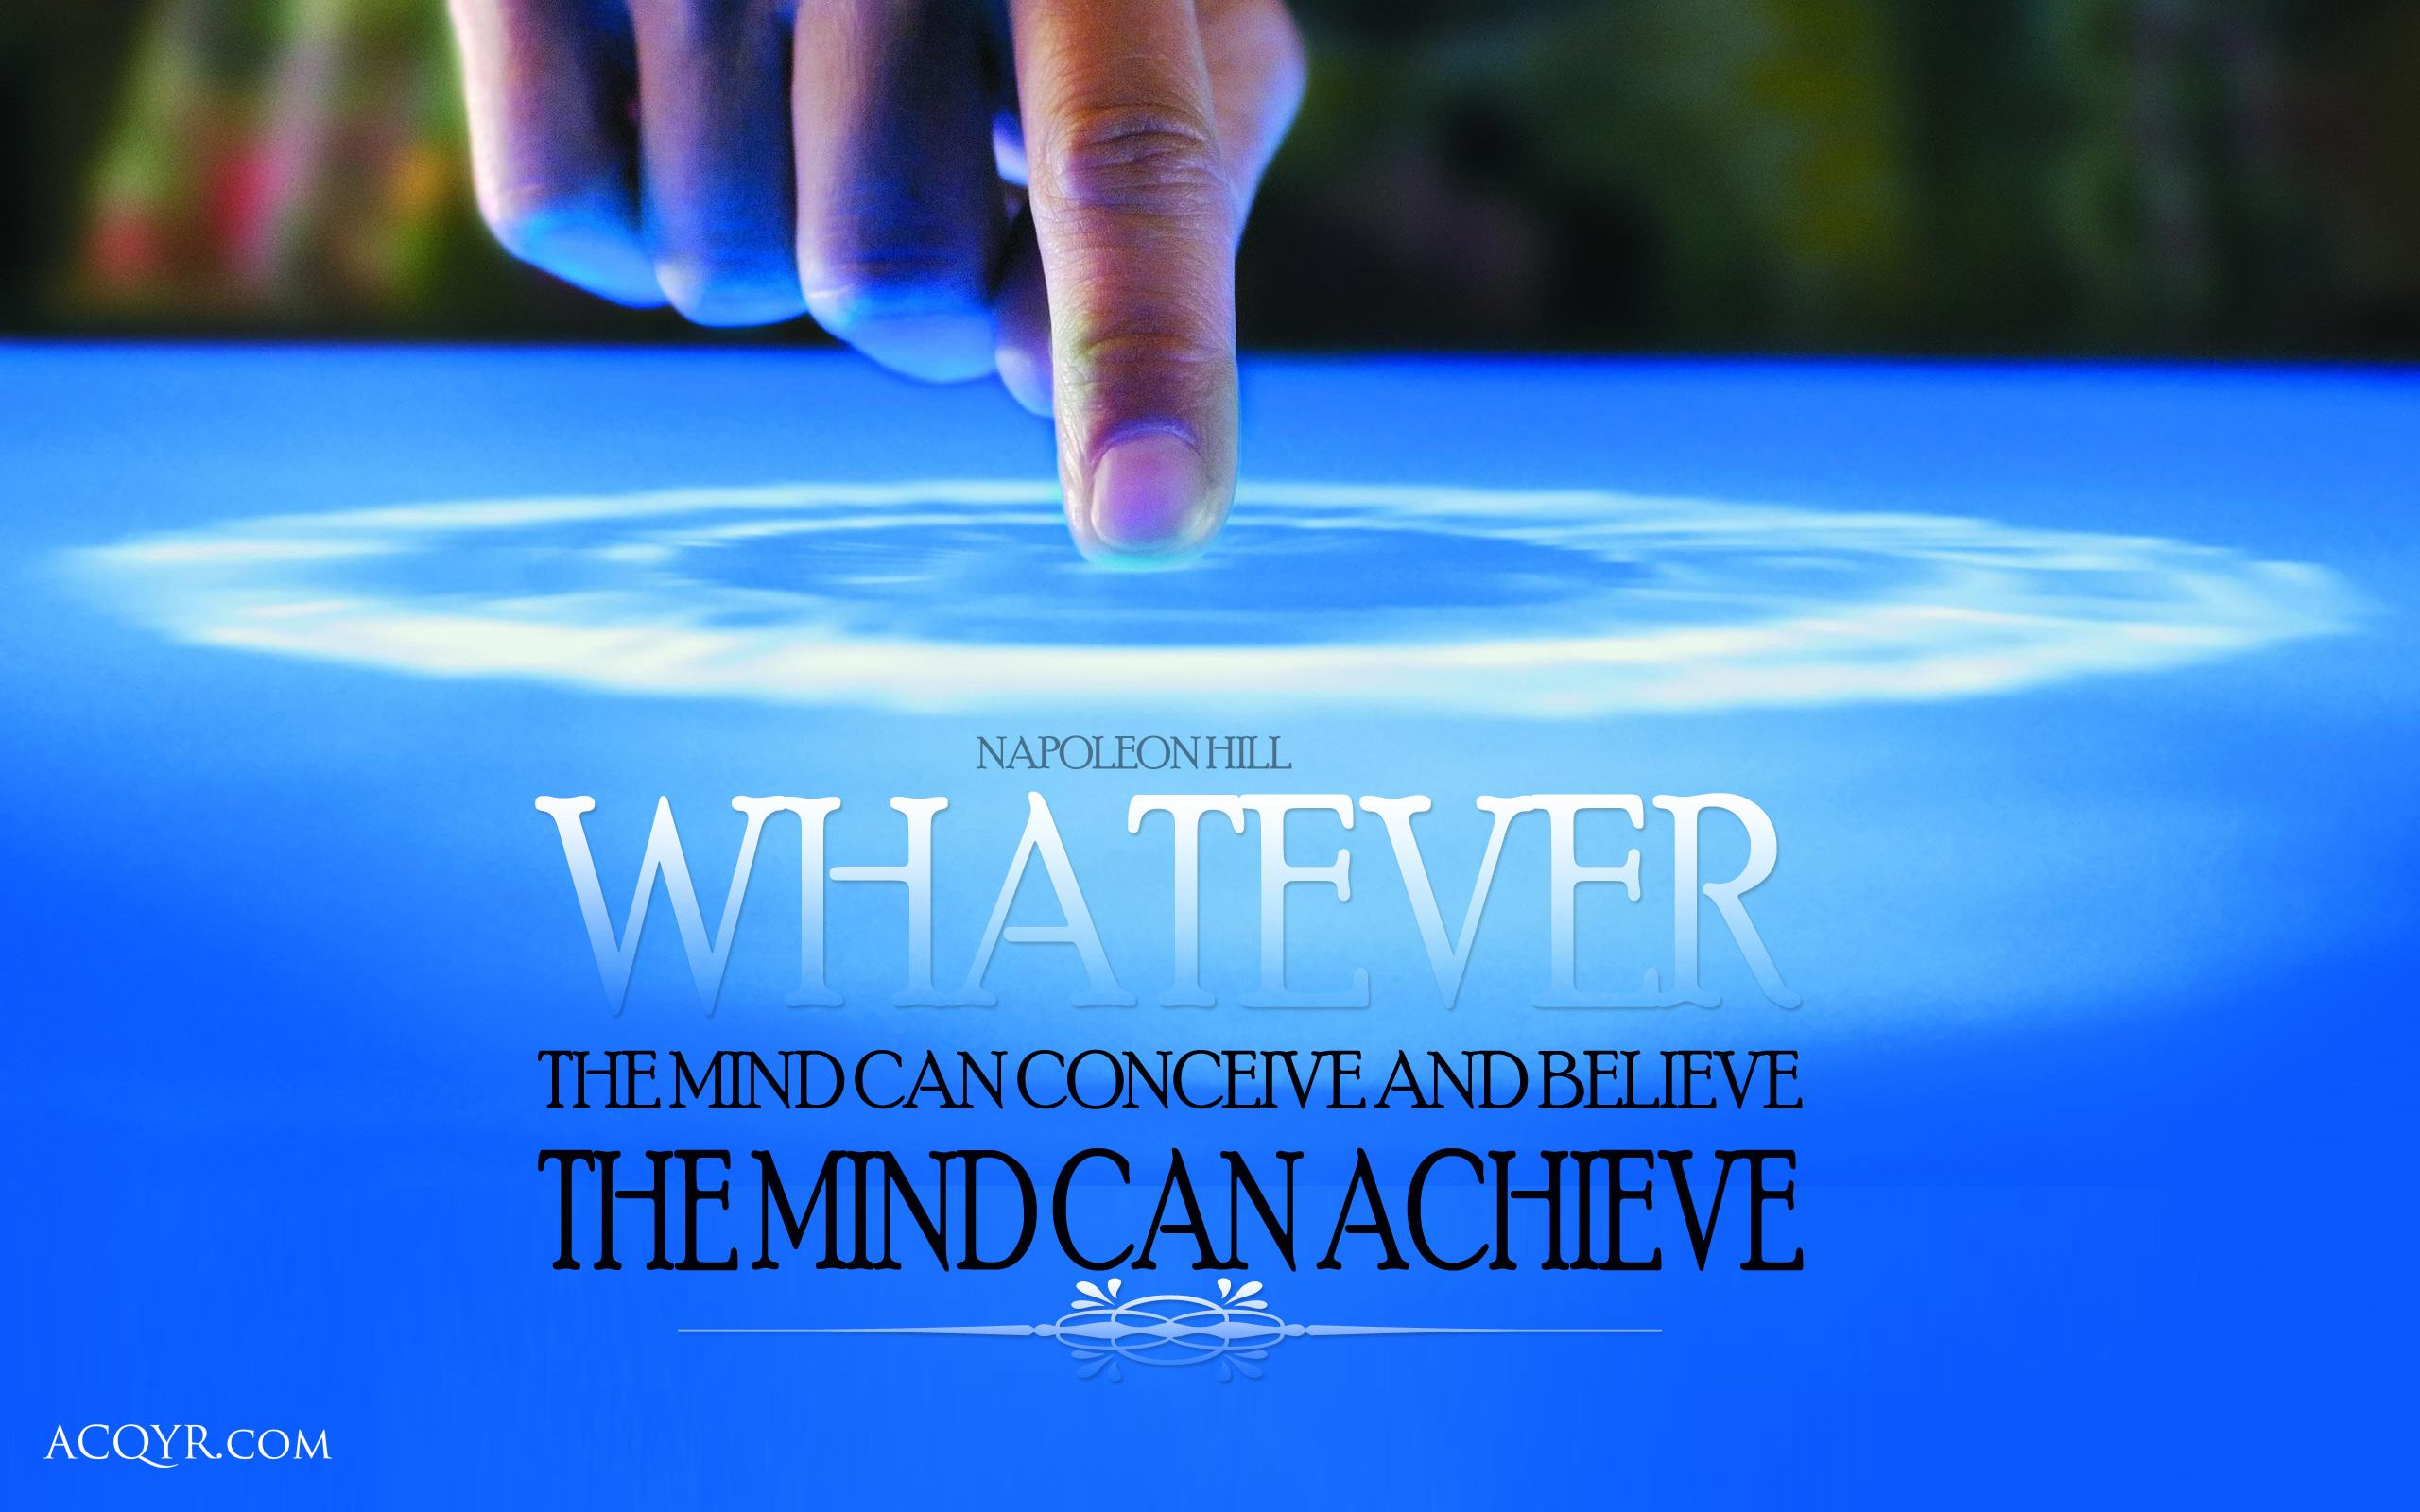
When you ‘imagine’ having already achieved what you really want – you are looking back to see the steps you took to make it happen. In this exercise, your subconscious mind doesn’t know you haven’t yet achieved your goals, it knows only the steps you took to make it happen. In this way, your mind and your energy (intentions) work together to attract the right people and circumstances to support you in achieving your outcomes.

Step 3. The magical “3-Step-Process”. Write down at least three things you need to do to get started for each goal. For example, if you want to get more sleep each night, what three things can you do to make this happen?

i) Set your watch to remind you when to go to bed.
ii) Have an early shower or go for a walk to encourage relaxation.
iii) Turn off the TV, phone or computer an hour before bed-time.

In this exercise you are outlining 3 Steps you need to take to either achieve your goal or move towards achieving it. This helps to break it down to smaller tasks so it doesn’t feel too big or overwhelming.

For goals that are a big or take longer to achieve, repeat the 3-Step-Process and ask yourself - 'what are the next 3 steps I need to take to move closer to my goal?’ Who do you need to call, what do you need to do? And, when you encounter a set back ask yourself - what’s something different I can do?

Remember to let go of the ‘what if…’ scenarios that negate the possibility of achieving your goals. Be persistent – just like reading a large novel, you read one page at a time until you reach the last page of the book and you have the satisfaction of completing it.

Remember – Give yourself a realistic timeframe in which to achieve your goal. Timing and measuring the steps to achieve your goal is important, as it keeps you accountable and gives you a structured plan to ensure success. Remind yourself daily of your desired outcome. See it in your mind (or create a vision board), feel it in your heart and in your body, believe it in your mind and in your spirit. Stay focused on your outcome, be open to new ideas, think positively, and you will attract the right people and situations to assist you.

#5. Conversations With a Life Coach

Sometimes we may need to talk to someone we can trust. Sharing a problem with a friend or family member can make a huge difference to easing the burden of our troubles and provide helpful support in times of need. However, this may not always be an option or it may not be desired.

A Life Coach is a professional who can give the support and guidance we may need at different times in our life. It could be to talk over something small, discuss relationships that are not working, get advice on how to be better organized, or it might involve discussing more significant changes and life improvements.

The reasons may be endless, and they’re equally valid and important. Being able to speak with someone you can trust, is the first step to moving forward and creating momentum for change. When we do nothing, then nothing changes. Our health and wellbeing is essential and involves taking care of all aspects of our being, whether it’s the way we think, our emotional wellbeing, our physical health, or our connection to our spiritual self. When we ignore problems in the hope they will go away, inevitably they hang around and get worse. Take action and decide to make a difference to YOU.

If you need to talk, or you want assistance in moving forward in your life, contact Rebecca@LivingWithSpice.com

YOU are important. It’s time to make your happiness and wellbeing a priority.

Rebecca provides life-coaching support either in person or over the phone or via Skype, and at affordable rates. Please contact Rebecca to make enquiries or discuss the options available to you. Phone: 0414 592 182 or email Rebecca@livingwithspice.com

#6. Trusting Your Intuition

Everyone is born with intuitive intelligence. However, many of us either don’t recognize it or we are too busy with distractions in our life which get in the way. How often have we said to ourselves “If only I had trusted my intuition (or listened to my gut feel) in the first place, I wouldn’t be in this predicament”?

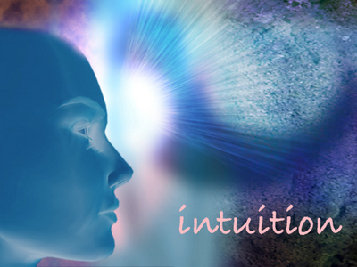
Our intuition is our inner guide or inner voice that we experience. We notice it as a subtle emotional response to our experiences. When we say ‘trust your intuition’ it means to trust that inner sense of calm, knowing and certainty, without necessarily having all the facts.

Our instincts are more of an immediate and strong physical response to dangerous situations, people or places, and this results in the release of hormones in the body for taking survival action.

Both our intuition and our instincts are necessary for our survival. For thousands of years, people have relied on their physical instincts to ensure safety, experienced as the fight or flight response. Tuning into our intuition is helpful on another level, particularly for anticipating changes and making better life choices. It can help us in our relationships, our physical environment, our personal growth and in our connection with our spiritual self, Nature and the Divine.

We can recognize our intuition as that sense of ‘knowing’ which can guide us toward our intentions or interests. When our intentions in life are clear, our Intuition can guide us more clearly. Confusion happens when we become stuck in our mind and overwhelmed by our thoughts. Intuition is a two-way process, a bit like a GPS in the car. You need to give your ‘intuition’ a destination so it can provide you with information on how to get there. Clear directions means clearer guidance. My intuition will guide me to what needs to shift or change in my life when I am clear about my intentions.

Sometimes we have selective awareness, and we can ignore our intuition because we don’t want to hear what it’s telling us. To be open to our intuition, we need to say what we feel, and be receptive. It means accepting the ebb and flow of our lives and keeping our spirit awake and alive. It’s important to say what you love in your life, engage with this every day, and stay present to those feelings. When we shut down the ‘feeling’ part of our selves, we also shut down our spirit and our intuition, or inner guidance.

As human beings, we are informed of our world through our physical, mental, emotional and spiritual experiences. We need to keep each part of our self attuned and awake. So, practice listening or tuning in to your intuition – and trust it. Avoid allowing your thoughts to get in the way by over thinking and analyzing. At times weighing up the pros and cons is necessary to make informed decisions. At other times your intuition may better serve you for the choice you need to make. Go with that first ‘gut-feel’ and test it out. You will become more accurate the more often you trust it.

Practical tips to tap into your intuition may include asking yourself:

1. Are you coming from a place of fear or love? Is your choice based on fear of missing out or losing something, or are you experiencing calm and trust, regardless of the outcome, knowing that what is supposed to happen, will happen?

2. Is the guidance you are receiving coming from inside or outside yourself ie: family, friends or colleagues? If the latter, be mindful, that despite well-meaning intentions, there will always be a hidden agenda for the advice given. Your inner guidance or intuition will be an experience of calm and knowing about what to do and when to do it, without any hidden agendas.

3. How do you feel? Are you being driven by a subtle emotional response (your intuition) or a strong physical one (your instincts)? The kind of response will tell you if it’s your intuition guiding you, or your instincts.

4. Are you thinking or knowing? Go back to the beginning – what was your initial response – a knowing, or is your mind now going over all the details and collecting evidence to support your beliefs and judgments? If it’s the latter, you will become emotionally attached to the outcome and this makes it difficult to hear your inner voice over the mind’s strong opinions.

5. Self Understanding. Over time you will get to know how to tap into your intuition with better accuracy. Notice how you tick and how you make your choices in life. If you are experiencing a lot of worry and anxiety, chances are you are operating more from fear, confusion and competing thoughts, rather than trusting your inner voice and knowing. Knowing ‘you’ and trusting yourself is essential for developing more accurate intuition.

Remember, fear and doubt will lead you away from hearing your inner guide and trusting your Intuition. Choices you make will be based on past experiences, beliefs, judgments and self-sabotage. Your choices will either be’ worrying about getting it right’, or ‘worrying about getting it wrong’.

Choices made with a sense of calm, trust and knowing, without attachment to the outcomes, are a result of following your Intuition. So let go of needing to over-analyze and be in control. Allow the flow of your Intuition to guide and lead you to where you really want to go.

# 5. Youths Volunteer in Cambodia – My Daughter’s Effect on a Nation Desperate to Learn.

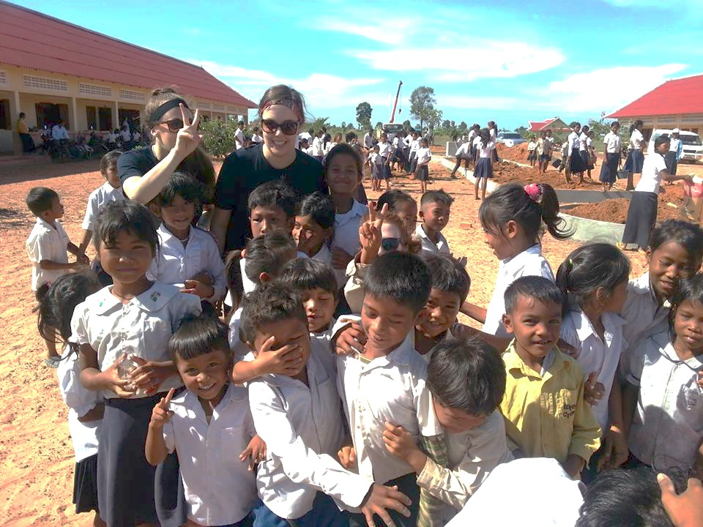
The moment the last university exam was done and dusted, my daughter Sasha and three other students made their way to Cambodia to volunteer one month of their time, and share their knowledge and skills in a small rural community outside of Siem Reap.

Desperate to learn English, Cambodian children and their parents, are keen to improve their education and their chances for a better life. The Australian organization, Antipodeans Abroad, provides young Australians the opportunity to visit developing countries to experience a different life and culture, and to contribute by providing useful resources from money raised, and basic education in English, Maths and Health.

The desire of the Cambodian people to learn and improve their education, is strong and deeply ingrained. Since the country suffered dreadfully from the destruction of war and the on-going problem of landmines, rebuilding their lives and re-establishing education as a priority has become a desperate desire and a necessity for now and future generations.

Many Australian volunteers, largely university students, are regularly visiting Cambodia with the desire to make a difference. For most Cambodians their greatest needs are quite basic, such as having a water-pump in their village so they don’t need to walk miles to collect water; or access to a bicycle to shorten the journey and to attend school. Basic health education for the men and women is also a necessity, such as learning how to avoid sickness from uncooked food, the importance of sex education, or even how to treat themselves for cuts and abrasions. They have many needs and often providing supplies is the easier option. However, the better sustainable solution is to help improve the skills and education of the Cambodian Teachers, so they in turn can teach the children and parents. In this way the Cambodian community becomes more empowered to manage their own lives and their future.
Figure 2 - Sasha and Rachael deliver a bicycle

For most Cambodian children, education is either not available or inaccessible, and is restricted to primary school levels. Many children who are bright and capable of learning do not have the option to progress to high school. Volunteers who come to these villages sporadically throughout the year, have a big heart and a desire to help, but often there is little organization or sustainability as far as educational programs or follow-up for the children’s progress. Consequently what is being taught cannot be practiced or re-enforced. There is clearly opportunity to do more to empower these people in a sustainable way that ensures a better future.

The experience of these four young women awakened their understanding and appreciation of the needs of our ‘brothers and sisters’ around the world. By volunteering their time, education, and skills they were able to provide the children and adults with hope and skills for the future, helpful resources, and make an unforgettable personal connection with this Cambodian community.

#8. Life Enhancement Workshops
Would you like to experience more happiness, fulfillment and productivity in your life, work and relationships? You may be interested in attending our Living With Spice program.
Location: Neutral Bay
Time: Monday (or Wednesday) evenings, 7-9pm.
Cost: $60 per month (4 sessions)

We aim to help you create a life that you love. Learn how to develop your personal communication skills, tune in to your intuition or inner guidance, become better organized at work and home, and achieve health and wellbeing in all aspects of your life. Learning how to love the person you are is key to living a life that is happy and fulfilling.

You can book your attendance on a monthly basis, meet other like-minded people and enjoy enhancing your life and relationships.

Book early to ensure your place. Email Rebecca@livingwithspice.com to register.

Classes begin Monday 3rd February or Wed 5th February if the Monday class is full.

#9. Events

Travelling With Spice - Social Events, 2014
In February and March we will be holding social events in Sydney and Wollongong so you can find out more about our unique travel experiences for women over 40. Dates will be published on www.travelcharm.com.au and www.livingwithspice.com shortly.
Cindy from Travel Charm will also speak about travel experiences for mixed groups. Men and women are welcome to these social events.
Film Screening and Fundraiser – “I Am A Girl”
Wednesday 26th March (Sydney), 7.00 – 9.00pm. Proceeds from the evening will go to Charities – “Because I Am A Girl” and “Plan” who support young girls in developing countries.

Living With Spice wishes you a wonderful 2014.
Your life is what you make of it, so make it count, and make it great!
Come back to loving YOU and loving your life.
Don’t forget to…..
- Laugh lots
- Give and receive heaps of hugs
- Smile daily
- Get plenty of sleep
- Eat healthfully
- Love yourself, because you deserve it.
- And, be YOU – no one else can.

Subscribe to Our Monthly Newsletter!
We hope you have enjoyed our first E-News for 2014. Notably we have started with a big bang! Subsequent E-Newsletters will be delivered to you each month. Please pass it on to your friends and family. New subscribers can email Rebecca@livingwithspice.com
If you wish to change your preferences, please click here to unsubscribe.

